Comparative Analysis: Gemma 7B vs. Mistral 7B

The LLM war between tech giants, which started with OpenAI’s GPT models and the wild success of ChatGPT isn’t limited anymore to just “who does it better?”. Now, with every major tech company releasing open-source LLMs, it’s more about “who does it better and for free?”.
Google, albeit quite late, has joined the open-source LLM race by releasing its Gemma models. Gemma 2B and 7B are the latest, open-source transformer-based large language models released by Google. Gemma 7B is competing directly with Mistral 7B, another hugely capable open-source LLM developed by the European AI startup called Mistral AI.
In this article, we’ll pit Gemma 7B against Mistral 7B, compare them across various benchmarks and parameters, and determine which model is best for what application.

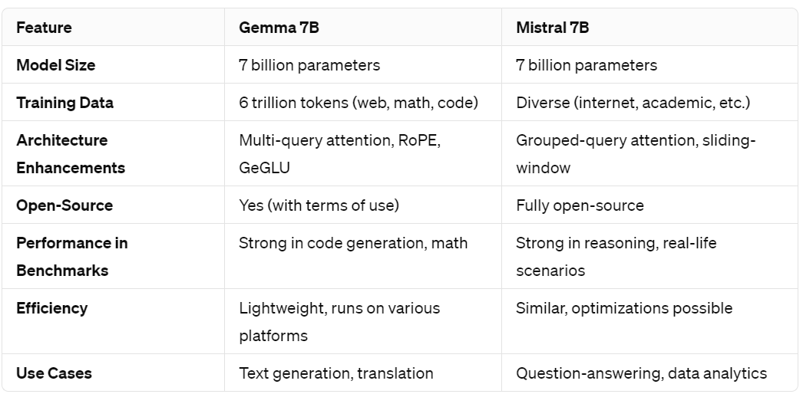

Gemma 7B: Development and Design
The Gemma 7B language model is a product of Google DeepMind's Gemini research program. Gemma has been designed using the same research as the Gemini AI models.

Key Features and Architecture of Gemma 7B
Gemma 7B has a transformer-based architecture - a standard approach in modern NLP models. The model is designed with several key features that enhance its performance and versatility:
- Model Size: Gemma 7B is a 7-billion-parameter model, making it significantly large and capable of handling complex language tasks.
- Open-Source: Gemma 7B is an open-source and open-weight model, however, it requires an acceptance of Gemma Terms of Use to avoid misuse.
- Training Data: The model is trained on a diverse dataset comprising 6 trillion tokens, including web documents, mathematics, and code. This extensive training helps the model develop a broad understanding of various topics and contexts.
- Architecture Enhancements: Gemma 7B incorporates multi-query attention, multi-head attention, RoPE embeddings, GeGLU activations, and a specific normalizer location. These enhancements contribute to the model's ability to process and generate text effectively.

Mistral 7B: Development and Design
Mistral AI is a research group that creates open-source, state-of-the-art language models. The company aims to democratize access to powerful language models by providing open-source alternatives to commercial models. Mistral 7B is one of their first LLMs and it was made open-source.

Key Features and Architecture of Mistral 7B
- Model Size: Mistral 7B is a 7-billion-parameter model, similar in scale to Gemma 7B, making it capable of handling complex language tasks.
- Training Data: The model is trained on a diverse dataset, including a wide range of text from the internet, academic papers, and other sources. This training helps the model comprehensively understand language and its nuances.
- Architecture: Mistral 7B also utilizes a transformer-based architecture. Additionally, it uses:
- Grouped-Query Attention: This technique adds relevant information to the input, allowing for more efficient processing and improved task accuracy.
- Sliding-Window Attention: This approach helps the model analyze sequential data effectively.
- Byte-fallback BPE (Byte Pair Encoding) tokenizer: This method allows the model to handle various types of text formats, including code and special characters.
- Fully Open-Source: Mistral AI provides access to the model's weights and training code, allowing the developer community to use, modify, and improve the model.
- Performance: According to the official paper, “Mistral 7B outperforms the previous best 13B model (Llama 2) across all tested benchmarks, and surpasses the best 34B model (LLaMa 34B) in mathematics and code generation. Furthermore, Mistral 7B approaches the coding performance of Code-Llama 7B, without sacrificing performance on non-code related benchmarks.”

Mistral 7B Vs. Gemma 7B: Performance Comparison

A. Benchmark Scores and Evaluation Metrics
Google compared the performance of Gemma 7B to all other major open-source LLMs, including Mistral 7B. It should be noted that individual developers and testers who compared the two models experienced different results, which we will explore in a moment.

Academic Benchmarks (e.g., HumanEval, GSM8K, MATH, AGIEval)

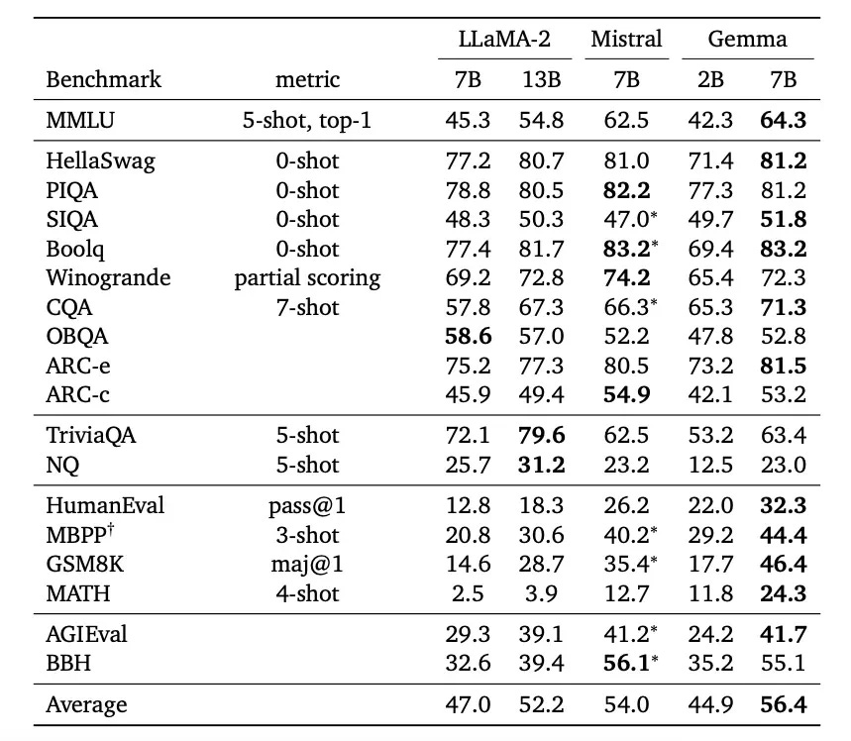
Source
- HumanEval: Gemma 7B demonstrates a strong performance in code generation tasks compared to Mistral 7B (32.3 vs 26.2).
- GSM8K: In mathematics problem-solving, Gemma 7B shows superior performance to Mistral 7B (46.4 vs 35.4).
- MATH: Gemma 7B excels in solving mathematical problems in comparison to Mistral 7B (24.3 vs 12.7).
- AGIEval: Gemma 7B performs well in general AI evaluation tasks, showcasing its versatility across various domains (41.7 vs Mistral’s 41.2).
PIQA, Boolq, Winogrande, Arc-c, and BBH were the benchmarks where Mistral 7B overshadowed Gemma 7B.
Based on this assessment, Gemma 7B would excel in tasks requiring dialogue, mathematics, and code generation. Mistral 7B would be better suited for commonsense reasoning, coreference resolution, question answering, creativity, and advanced reasoning.

B. Efficiency and Resource Utilization

Model Size and Computational Requirements
- Gemma 7B: As a 7-billion-parameter model, Gemma 7B requires significant computational resources for training and inference. It is, however, way more lightweight than traditional LLMs. Google added that pre-trained and instruction-tuned Gemma models can run on your laptop, workstation, or Google Cloud, with deployment options for Vertex AI and Google Kubernetes Engine (GKE).
- Mistral 7B: Mistral 7B, also a 7-billion-parameter model, has similar computational requirements to Gemma 7B. However, its fully open-source nature allows for optimizations that can improve efficiency.

Inference Speed and Latency
- Gemma 7B: The inference speed of Gemma 7B is generally fast, but it can vary depending on the complexity of the task and the hardware used. Latency is typically low.
- Mistral 7B: Mistral 7B’s latency and inference speed are both comparable to Gemma 7B.

Integrations
Gemma 7B: Gemma 7B's integration with the Keras deep learning framework facilitates its use in developing machine learning models. This integration allows developers to leverage Keras's extensive library of tools and functionalities.
Gemma 7B also supports Low-Rank Adaptation (LoRA) fine-tuning, a technique that enables efficient customization of the model without the need for extensive retraining.
Mistral 7B: Mistral 7B offers a range of deployment options, allowing it to be integrated into various platforms and systems. This flexibility is crucial for developers looking to deploy the model in different environments.
Mistral 7B's reference implementation provides a starting point for developers to customize and adapt the model to their specific requirements.

C. Safety and Ethical Considerations
Both Gemma 7B and Mistral 7B have reasonable red teaming and debiasing mechanisms. Since Mistral AI has publicly released the weights of all of its models, including the 7B, it is easier to manipulate than Gemma 7B.
This also means that the company cannot reinforce its safety and privacy standards as strictly as Google can with the Gemma open models since Gemma does require accepting user terms before enabling weights access.

Practical Applications and Use Cases
- Complex Text Generation: Gemma 7B excels in generating coherent and contextually relevant text, making it ideal for applications such as content creation, storytelling, and automated journalism.
- Question-Answering: Mistral 7B might be a better option to serve question-answering applications.
- Translation: Gemma 7B's language capabilities extend to translation tasks, where it can be used to translate texts between multiple languages with high accuracy.
- Multimodal Applications: Gemma 7B is a decoder-only model, whereas Mistral 7B possibly can be fine-tuned by AI professionals for multimodal tasks.
- Data Analytics: Mistral 7B’s ability to process and analyze large datasets makes it useful in data analytics. Predictive modeling, trend analysis, and decision-making processes in sectors like finance, healthcare, and insurance are where this model can find good use.

Gemma Vs Mistral: Independent Evaluations
The comparison we have presented to you up until here is based on the technical report and research papers released by Google and Mistral AI about the respective models.
The developer community, however, has run its own tests on these models. A few key aspects that stand out include:
- Gemma’s quantized versions on HuggingFace don’t give as high-quality results as the versions on Perplexity Labs and NVIDIA Playground. When tested using the quantized version, the model was often subpar to Mistral 7B.
- Mistral 7B outperforms Gemma 7B in logical reasoning and real-life scenarios in these independent tests. This is somewhat contradictory when seen against the benchmark reports.
- In code-generation tasks, Gemma outperforms Mistral 7B.
- Consistency is another area where Gemma can significantly improve.

